1.  **Form Validation using PHP**

* 1. Recreate the form provided below.
  2. On submit, PHP should check and validate fields.
  3. The form should be submitted to the validation.php file.
  4. The program should return to the same form even when an error occurs or not.
  5. Form fields marked asterisk (*) are required fields. They should not be empty ( form-with-required-errors.jpg)
  6. Another type of validation error related to different fields can be found in another image (form-with-other-validation-errors.jpg)

**Image 1:**

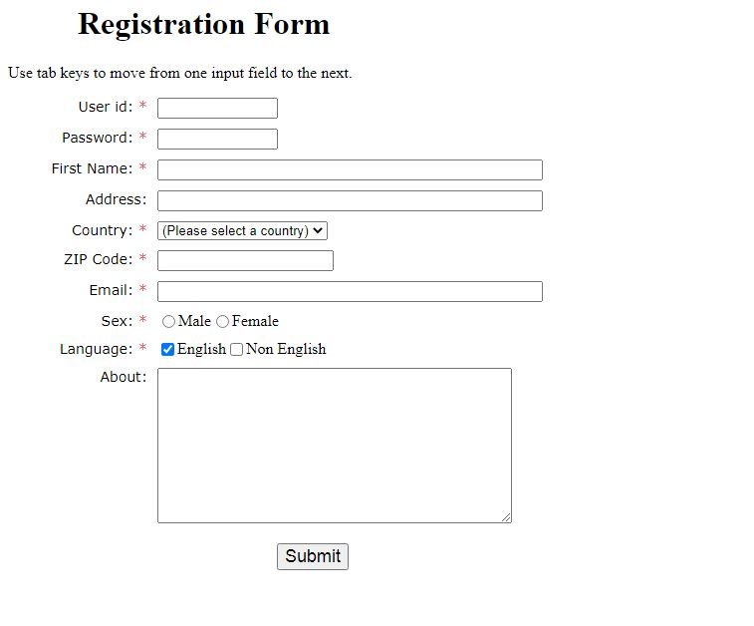

**Image 2:**

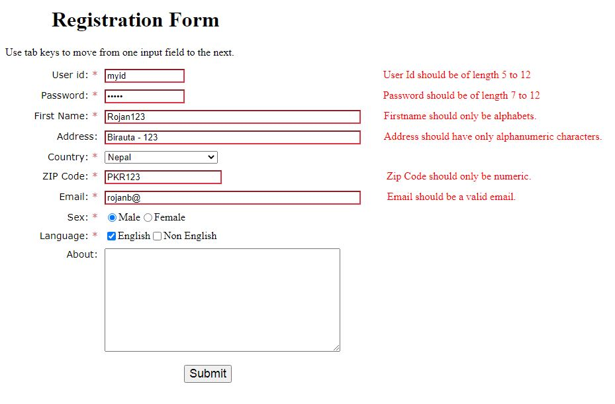**Image 3:**

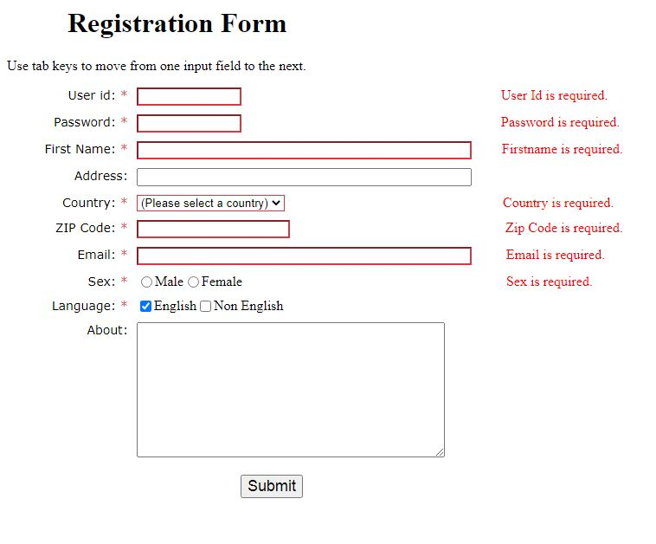

Answer: validation.php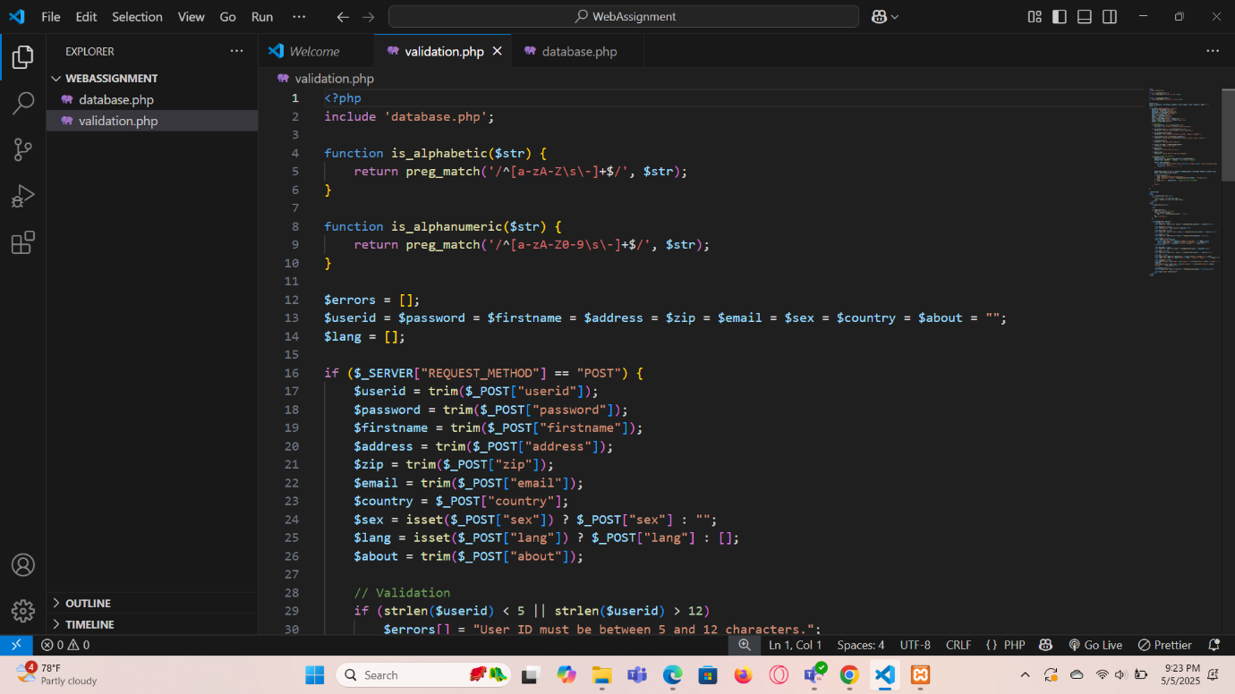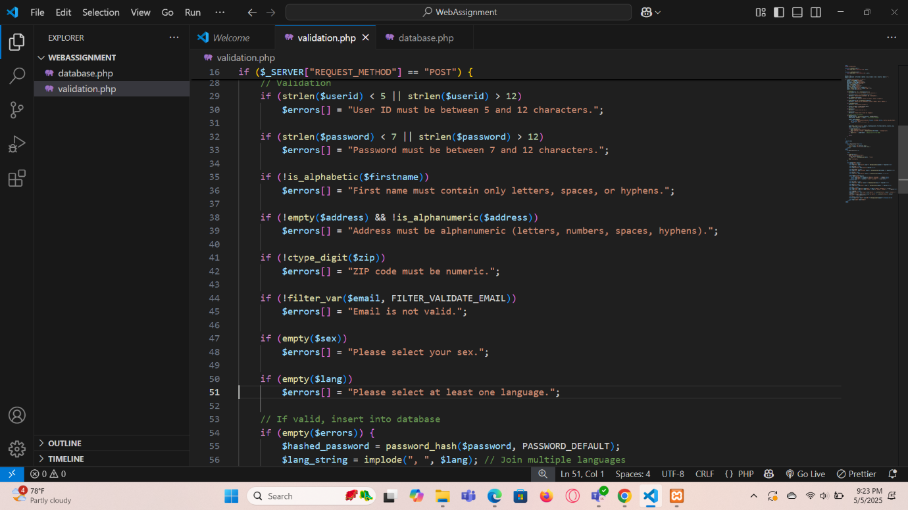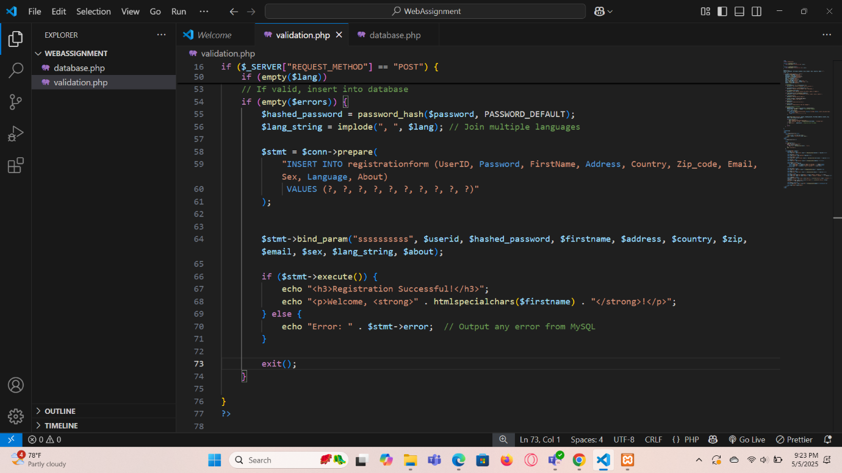

database.php: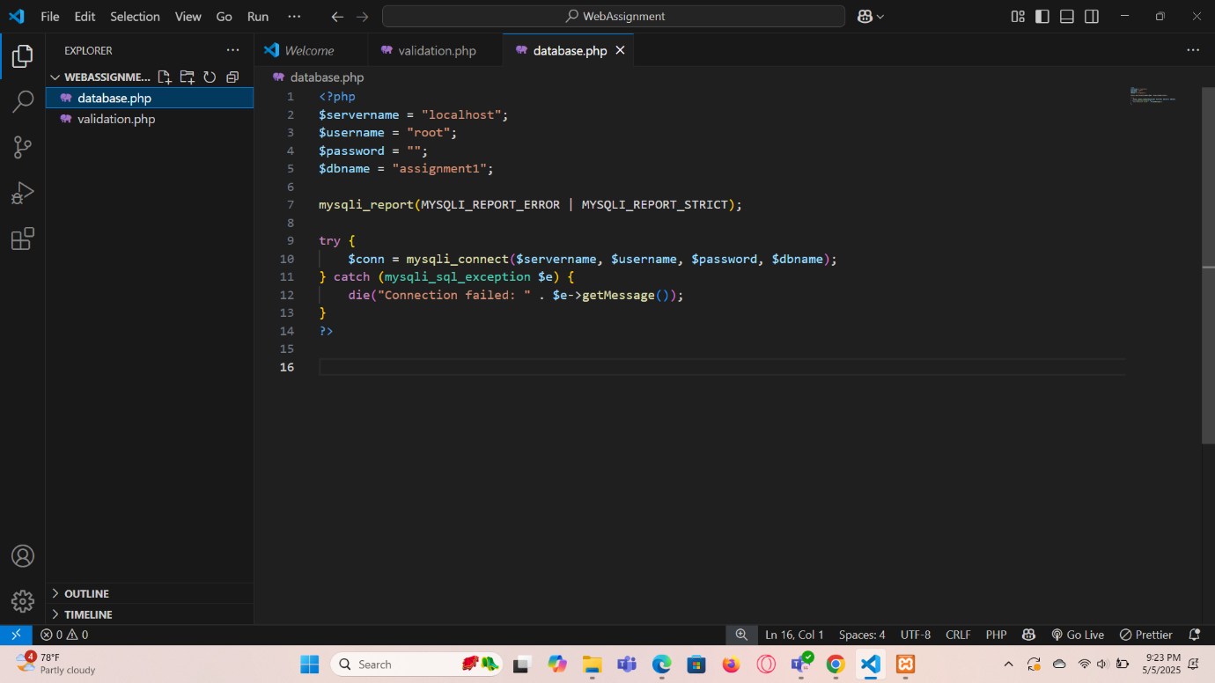

Output:

